LABduino – How To

This is a short introduction, how to build Wiring or Arduino hardware from MLAB modules.
The project Wiring is initiator from which Arduino started. There are list of natively supported microcontrollers.
Arduino:
(ATmega8), ATmega168, ATmega328, ATmega2560
Wiring:
ATmega128, ATmega1281, ATmega2561.

For example we have chosen Arduino Duemilanove with ATmega168 here. Bat another microcontrollers are possible.

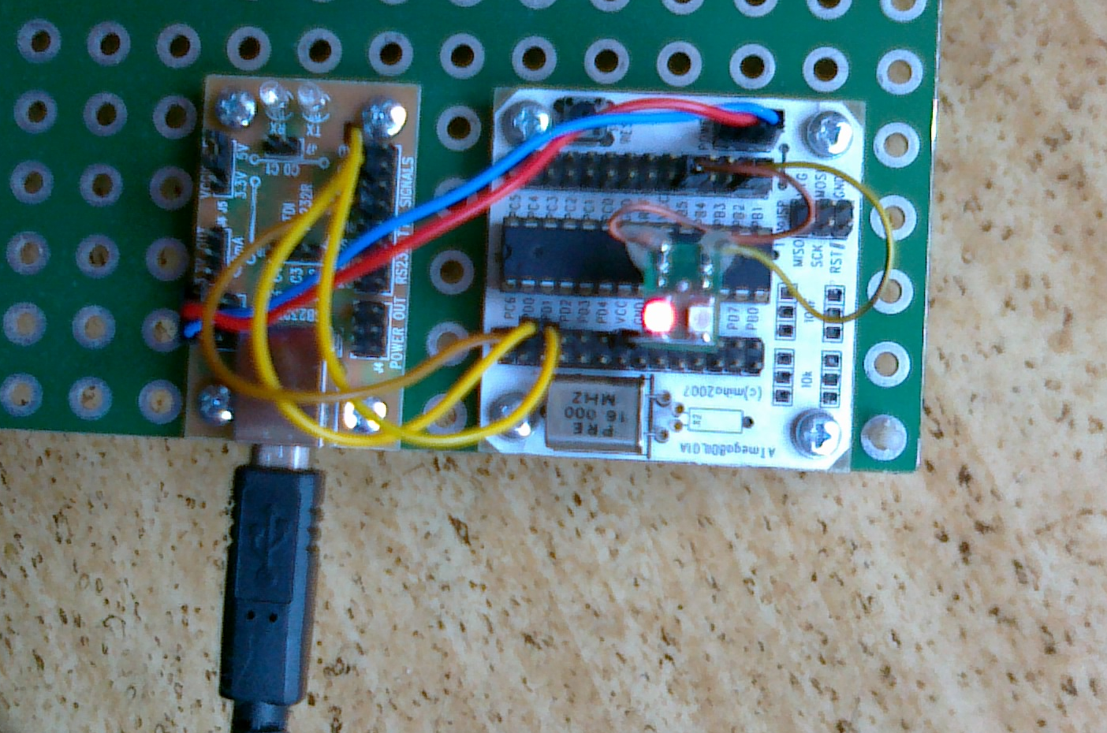

Setup of Hardware
We used modules ATmega8DIL01A and USB232R01B. We put ATmega168 with quartz 16MHz in to module ATmega8DIL01A.
End next we have to make interconnection which is described in this table:
ATmega8DIL01A | USB232R01B | Note
USB +5V | POWER | We have to use standard MLAB power cord 5V or we can interconnect only GND if the design is self-powered.
PD0 | TXD
PD1 | RXD
PC6 | RTS#
PB5 |  | Some LED should be connected here.
 | VCCIO SEL | We have to select 3,3V or 5V by design.

A LED blinking example
- Download the Arduino IDE from http://arduino.cc/en/Main/Software . (Or download Wiring from http://wiring.org.co/download/)
- Let’s run the IDE and open a sample project File > Examples > 1.Basics > Blink.
- Chose a type of board Tools > Board > Arduino Diecimila, Duemilanove, or Nano w/ ATmega168
- Connect USB232R01B with USB cable to the computer and set the appropriate communication port at Tools > Serial Port.
- Upload the compiled sample by “Upload to I/O board”.
- The LED connected to PB5 has to blink.

How to upload a bootloader to ATmega8DIL01A
If we have not bootloader inside our ATmega microcontroller we can burn one in to.
We have to have ATprogISPUSB02A for this task and a little changing is necessary in Arduino configurations files. There is a description for Windows 7 but modifications in other operating systems are similar.
- Add some lines to ….\arduino-xxxx\hardware\arduino\programmers.txt:
mlab.name=MLAB ATprogISPUSB
mlab.communication=serial
mlab.speed=115200
mlab.protocol=stk500v2
- Change one line in …\Users\user\AppData\Roaming\Arduino\preferences.txt
This line:
upload.using=BOOTLOADER
has to be replaced by this line:
upload.using=mlab
- And now please connect the ATprogISPUSB02A to your computer and select an appropriate port at Tools > Serial Port.
- Now, we can upload binaries directly with “Upload to I/O board” or we can upload bootloader with Tools > Burn Bootloader > MLAB ATprogISPUSB.
Of course we have to select an appropriate type of board before. For our example the Arduino Diecimila, Duemilanove, or Nano w/ ATmega168 is right choice.
(Uploading of bootloader takes some time. After successful uploading a LED connected to PB5 has to be blinking.)

Ports mapping
A table with mapping of Arduino ports to the real ATmega ports would be useful:
Arduino | ATmega8DIL01A | Note
D0 | RXD | PD0, if you disconnect USB232R01B
D1 | TXD | PD1, if you disconnect USB232R01B
D2 | PD2 | Digital I/Os.
D3/PWM | PD3 | Digital I/Os.
D4 | PD4 | Digital I/Os.
D5/PWM | PD5 | Digital I/Os.
D6/PWM | PD6 | Digital I/Os.
D7 | PD7 | Digital I/Os.
D8 | PB0 | Digital I/Os.
D9/PWM | PB1 | Digital I/Os.
D10/PWM | PB2 | Digital I/Os.
D11/PWM | PB3 | Digital I/Os.
D12 | PB4 | Digital I/Os.
D13 | PB5 | Digital I/Os.
A0 | PC0 | Analog inputs.
A1 | PC1 | Analog inputs.
A2 | PC2 | Analog inputs.
A3 | PC3 | Analog inputs.
A4 | PC4 | Analog inputs.
A5 | PC5 | Analog inputs.

And what to do if another microcontroller we need?
In that case we have to edit this file:
….\arduino-xxxx\hardware\arduino\boards.txt .

For example let say we need ATmega8.
O.K. We need ATMEGA801B and ATmega8 and 8MHz quartz.
Next steps are described here: http://todbot.com/blog/2009/05/26/minimal-arduino-with-atmega8/

